# Web Fonts for Andrew Joseph Alexander

**Font choices (2) for Andrew Joseph Alexander:**

**Source:** Google Fonts

**Link:** <https://fonts.google.com/specimen/Montserrat>

**Screen Shots:** 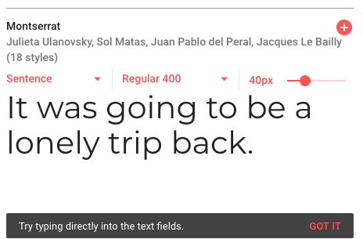

**Source:** Google Fonts

**Link:** <https://fonts.google.com/specimen/Boogaloo>

**Screen Shots:** 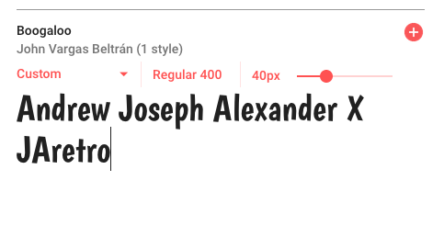

I chose these fonts because they are clean, attractive, and pleasing to the eye. I leaned toward using sans-serif fonts which will be clear enough to be a readable typeface that's appropriate for Andrew Joseph Alexander. The fonts legibility will hopefully add to a positive user experience. I liked Montserrat for its spacing qualities, and Boogaloo for its bold character and artistic style inspired by 1960's LP's and records.